IoT Milk Preservation System Documentation

Wiring Diagram (Textual Description)
ESP32 milk preservation — wiring diagram
DHT22 sensor — use a 10kΩ resistor between DATA and VCC (pull-up):
- Pin 1 (VCC) → ESP32 3V3
- Pin 2 (DATA) → GPIO4 (with 10kΩ pull-up to 3V3)
- Pin 4 (GND) → GND
LCD 16×2 with I²C backpack — only 4 wires needed:
- VCC → ESP32 VIN (5V)
- GND → GND
- SDA → GPIO21
- SCL → GPIO22
Relay module:
- VCC → VIN (5V)
- GND → GND
- IN → GPIO26
- COM/NO → your cooling unit (fridge/Peltier)
Buzzer & LED — both share GPIO27:
- Buzzer (+) → GPIO27, Buzzer (–) → GND
- LED (+) → GPIO27 via a 220Ω resistor, LED (–) → GND
Check summary if correctly connected
- ESP32 → DHT22 Sensor: Pin 4 → Data, 3.3V → VCC, GND → GND
- ESP32 → LCD (I²C): SDA (GPIO 21) → SDA, SCL (GPIO 22) → SCL, 5V → VCC, GND → GND
- ESP32 → RGB LED: GPIO 26 → Red, GPIO 27 → Green, GPIO 14 → Blue, common cathode → GND
- ESP32 → Relay: GPIO 33 → IN, 5V → VCC, GND → GND
- ESP32 → Buzzer: GPIO 25 → +, GND → -

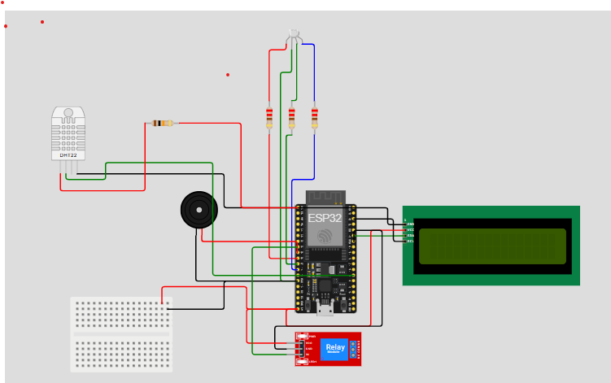

2. Flow Chart (Logic Overview)
Start / Setup

│
┌───────▼────────┐
│ Read Temp & Hum│
└───────┬────────┘
│
┌─────────▼─────────┐
│ Sensor Error? │
└───────┬───────────┘
│Yes
▼
Display "Sensor Error"
Turn OFF all outputs
│
└───────────────► Loop
│No
▼
┌───────────────────────────────┐
│ Check Temperature Thresholds │
└───────────────────────────────┘

Blue ≤2°C → Too Cold
Red 5–8°C → Too Hot
Flash Red >8°C → Critical Temp

│
▼
┌───────────────────────────────┐
│ Check Humidity Thresholds │
└───────────────────────────────┘
Yellow <70% → Low Humidity
Green 70–79% → Moderate
Cyan 80–90% → Optimal
Purple 91–95% → High Humidity
Flash Purple/Red >95% → Critical Humidity
│
▼
┌─────────────-──┐
│ Update LCD │
│ (Alternate T/H)│
└───────┬────-───┘
│
▼
Loop

3. Milk Test Criteria Documentation
Test ID | Temp Range (°C) | Humidity Range (%) | System Status | LED Color | Relay | Buzzer | Meaning for Milk Preservation / Risks
TEST 1 | ≤ 2 | 80–90 | Too Cold | Blue | OFF | ON | Milk may freeze; ice crystals disrupt proteins. Overcooling risks poor texture. In cold‑room collection centers, improper chilling can mask adulteration or contamination.
TEST 2 | 3–5 | 80–90 | Safe Range | Cyan | OFF | OFF | Ideal preservation. Milk remains stable for pooling/processing. Automated monitoring ensures adulterated or contaminated milk is detected before mixing.
TEST 3 | > 5 | 80–90 | Too Hot | Red | ON | ON | Spoilage risk begins. Warm conditions accelerate bacterial growth. Unscrupulous farmers may exploit warm storage to dilute milk with water, compromising quality.
TEST 4 | > 8 | 80–90 | Critical Heat | Red Flash | ON | ON | High contamination danger. Milk should be isolated before mixing. At this stage, bacterial load is unsafe for infants and poses serious health risks.
TEST 5 | Any | < 70 | Low Humidity Warning | Yellow | OFF | OFF | Environment too dry; excessive ventilation reduces cooling efficiency. Poor storage conditions increase risk of adulteration detection failures.
TEST 6 | Any | 70–79 | Moderate Humidity | Green | OFF | OFF | Acceptable but below ideal. Continuous monitoring needed to prevent unnoticed contamination from sick cows or poor hygiene.
TEST 7 | Any | 80–90 | Optimal Humidity | Cyan | OFF | OFF | Best humidity for dairy preservation. Stable conditions support rapid, automated quality testing and accountability in supply chains.
TEST 8 | Any | > 90 | High Humidity Warning | Purple | OFF | ON | Excess moisture causes condensation, mold, and bacterial contamination. Mixing contaminated milk with good milk compromises entire batches, highlighting the need for automated rejection systems.

